**INTRODUCTION**

**Natural Language Processing (NLP)** is a field of artificial intelligence that focuses on enabling computers to understand, process, and generate human language. It combines computational linguistics with machine learning and deep learning techniques to analyze text and speech, allowing machines to interpret language similarly to humans.

NLP is widely used in various applications, including chatbots, virtual assistants, machine translation, sentiment analysis, and speech recognition. It plays a crucial role in industries such as healthcare, finance, e-commerce, and customer service by automating tasks like text analysis, document summarization, and voice-to-text conversion.

With advancements in deep learning and transformer models like GPT and BERT, NLP continues to evolve, making human-computer interactions more seamless and natural. As the technology progresses, it is expected to further enhance decision-making, improve user experiences, and revolutionize the way we communicate with machines.

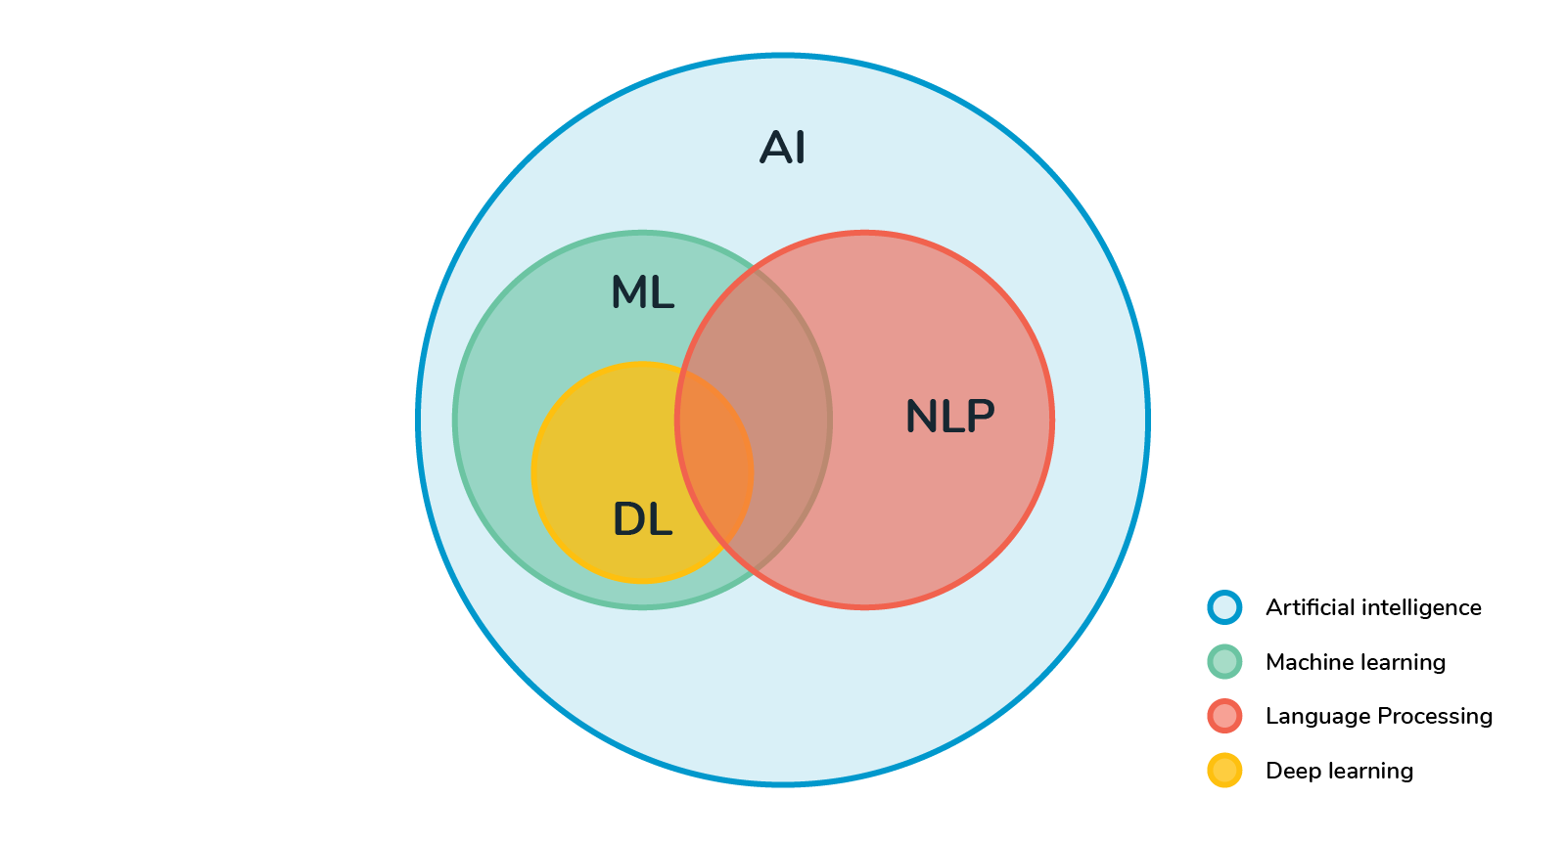Natural Language Processing (NLP) is a field of artificial intelligence (AI) that enables computers to understand, interpret, and generate human language. The working principle of NLP involves several key steps:

1. **Text Preprocessing**

Before processing, raw text needs to be cleaned and prepared:

* Tokenization – Splitting text into words or sentences.
* Stopword Removal – Removing common words like "the," "is," "and."
* Stemming/Lemmatization – Reducing words to their base or root form (e.g., "running" → "run").
* Part-of-Speech (POS) Tagging – Identifying nouns, verbs, adjectives, etc.

2. **Feature Extraction**

Text is converted into a numerical format so that it can be processed by algorithms:

* Bag of Words (BoW) – Counting word occurrences.
* TF-IDF (Term Frequency-Inverse Document Frequency) – Measuring word importance.
* Word Embeddings (Word2Vec, GloVe, BERT, etc.) – Representing words as dense vectors that capture meaning.

3. **Processing & Understanding**

Different models and techniques are used to analyze text:

* Rule-based NLP – Uses predefined linguistic rules.
* Statistical NLP – Uses machine learning models trained on large datasets.
* Deep Learning NLP – Uses neural networks (e.g., transformers like BERT, GPT).

**History of Natural Language Processing (NLP)**

1. **Early Foundations (1940s-1950s)**

NLP began with attempts at machine translation, notably the **Georgetown-IBM experiment** in 1954, and Alan Turing's proposal of the **Turing Test** (1950), which set the stage for AI and language understanding.

1. **Rule-Based Systems (1960s-1970s)**

Early NLP systems used **linguistic rules** and theories like **Chomsky's generative grammar** to process language. **ELIZA**, a simple chatbot from 1966, was an early example of text-based interaction.

1. **Statistical Models (1980s-1990s)**

With the rise of **machine learning**, **Hidden Markov Models** and data-driven approaches replaced rule-based methods, improving tasks like **speech recognition** and **text classification**.

1. **Deep Learning (2000s-2010s)**

Neural networks, particularly **Word2Vec** (2013) for word embeddings, marked a shift to data-intensive, learning-based methods. The **Transformer** (2017) and models like **BERT** and **GPT** revolutionized NLP, allowing systems to handle context and long-range dependencies.

1. **Modern NLP (2020s)**

Large models like **GPT-3** showcase the power of **pretrained** models, and there's growing interest in **multimodal AI** (combining text, images, etc.) and addressing **ethical issues** like **bias** and **fairness**

**Techniques key in Natural Language Processing (NLP)**

**1. Tokenization**

* **Definition**: Splitting text into individual units, such as words, sentences, or subwords.
* **Example**: The sentence "I love programming." would be tokenized into: ["I", "love", "programming", "."]
* **Types**:
  + **Word tokenization**: Breaks down text into words.
  + **Sentence tokenization**: Breaks text into sentences.

**2. Part-of-Speech Tagging (POS)**

* **Definition**: Assigning each word in a sentence its grammatical category (noun, verb, adjective, etc.).
* **Example**: In "The cat sleeps," POS tagging assigns "The" as a determiner (DT), "cat" as a noun (NN), and "sleeps" as a verb (VB).

**3. Named Entity Recognition (NER)**

* **Definition**: Identifying and classifying named entities (people, locations, organizations, etc.) in text.
* **Example**: In the sentence "Apple Inc. was founded in Cupertino," NER identifies "Apple Inc." as an organization and "Cupertino" as a location..

**5. Dependency Parsing**

* **Definition**: Analyzing the grammatical structure of a sentence to identify relationships between words (e.g., subject, object).
* **Example**: In the sentence "She gave him a book," the parser identifies "She" as the subject, "gave" as the verb, "him" as the indirect object, and "book" as the direct object.

**6. Word Embeddings**

* **Definition**: Representing words in vector space based on their semantic meaning, allowing for comparison and similarity.
* **Popular Methods**:
  + **Word2Vec**: A model that learns word representations based on context.
  + **GloVe**: A model that generates word vectors by factorizing a word co-occurrence matrix.
  + **FastText**: Extends Word2Vec by considering subword information.
* **Example**: The word "king" might be represented as a vector that is closer to "queen" than to "apple."

**7. Transformers (BERT, GPT, etc.)**

* **Definition**: Transformer models are deep learning architectures that rely on self-attention mechanisms to process and generate language. They allow for parallel processing and long-range dependencies.
* **BERT**: Bidirectional Encoder Representations from Transformers, designed for understanding context in sentences.
* **GPT**: Generative Pre-trained Transformer, designed for generating human-like text.
* **Applications**: Question answering, text summarization, sentiment analysis, etc.

**8. Text Classification**

* **Definition**: Assigning categories or labels to text based on its content.
* **Applications**: Sentiment analysis, spam detection, topic categorization.
* **Example**: Classifying a review as positive or negative.

**9. Machine Translation**

* **Definition**: Automatically translating text from one language to another.
* **Example**: Translating "Hello" to "Bonjour" using machine translation.

**10. Sentiment Analysis**

* **Definition**: Determining the sentiment or emotion expressed in text, usually classified as positive, negative, or neutral.
* **Example**: "I love this movie!" would be classified as positive sentiment.

**11. Text Summarization**

* **Definition**: Producing a concise summary of a longer text while retaining its key points.
* **Types**:
  + **Extractive summarization**: Extracting key phrases or sentences directly from the original text.
  + **Abstractive summarization**: Generating new sentences to summarize the content in a more human-like manner.

**14. Speech Recognition**

* **Definition**: Converting spoken language into written text.
* **Example**: Converting the spoken words "Hello, how are you?" into the text "Hello, how are you?"

**15. Text-to-Speech (TTS) and Speech-to-Text (STT)**

* **Definition**: Converting text into speech (TTS) or converting speech into text (STT).
* **Applications**: Virtual assistants, transcription services, accessibility tools.

**Machine learning in NLP**

**1. Supervised Learning:**

* **Uses labeled data** to train models for tasks like sentiment analysis, text classification, and Named Entity Recognition (NER).

**2. Unsupervised Learning:**

* **Finds patterns in unlabeled data** like topic modeling, word embeddings (Word2Vec, GloVe), and clustering text.

**3. Reinforcement Learning:**

* **Trains models through trial and error**, useful for dialogue systems and fine-tuning machine translation models.

**4. Deep Learning:**

* **Uses neural networks** like RNNs, LSTMs, and transformers (BERT, GPT) for advanced NLP tasks like translation, summarization, and text generation.

**5. Transfer Learning:**

* **Pre-trains models on large datasets** (e.g., BERT, GPT) and fine-tunes them for specific tasks, improving efficiency and performance.

**6. Seq2Seq Models:**

* **Transforms input sequences into output sequences**, used in machine translation, speech recognition, and chatbots

**Deep learning in Natural Language Processing (NLP)**

Deep learning has significantly advanced Natural Language Processing (NLP) by using neural networks with many layers (deep neural networks) to process language more effectively. Here's a quick summary of how deep learning is applied in NLP:

**1. Recurrent Neural Networks (RNNs)**

* **Use**: Designed for sequential data (e.g., text), RNNs process words one by one and maintain context.
* **Limitations**: Struggle with long-term dependencies, leading to the development of more advanced models.

**2. Long Short-Term Memory (LSTM)**

* **Use**: A type of RNN designed to overcome the vanishing gradient problem, making it better at remembering long-term dependencies.
* **Applications**: Machine translation, text generation, and speech recognition.

**3. Gated Recurrent Units (GRU)**

* **Use**: A simplified version of LSTM with fewer parameters, also effective for sequential data.

**4. Convolutional Neural Networks (CNNs)**

* **Use**: Typically used in computer vision, but in NLP, CNNs are applied to text classification and extracting features from text by treating it as a 1D signal.

**5. Transformers**

* **Use**: The current state-of-the-art architecture, transformers use **self-attention mechanisms** to capture long-range dependencies in text efficiently.
* **Applications**: Text generation (GPT), text understanding (BERT), machine

**6. Attention Mechanism**

* **Use**: Helps models focus on important parts of the input when making predictions. It's a key part of transformers and has vastly improved NLP performance.

**7. Word Embeddings (Word2Vec, GloVe, FastText)**

* **Use**: Represent words as vectors in a continuous space where semantically similar words are closer together, capturing meaning and relationships between words.

**Main Components of NLP**

* Natural language Understanding
* Natural language Generation

**Natural language Understanding**

[Natural language understanding](https://www.ibm.com/products/natural-language-understanding) is a subset of natural language processing, which uses syntactic and semantic analysis of text and speech to determine the meaning of a sentence. Syntax refers to the grammatical structure of a sentence, while semantics alludes to its intended meaning. NLU also establishes a relevant ontology: a data structure which specifies the relationships between words and phrases. While humans naturally do this in conversation, the combination of these analyses is required for a machine to understand the intended meaning of different texts.

**Natural Language Generation**

Natural language generation is another subset of natural language processing. While natural language understanding focuses on computer reading comprehension, natural language generation enables computers to write. NLG is the process of producing a human language text response based on some data input. This text can also be converted into a speech format through text-to-speech services.

**ADVANTAGES OF NATURAL LANGUAGE PROCESSING (NLP)**

* **Increased documentation efficiency & accuracy**

An NLP-generated document accurately summarizes any original text that humans can’t automatically generate. Also, it can carry out repetitive tasks such as analyzing large chunks of data to improve human efficiency.

* **Capability to automatically create a summary of large & complex textual content**

Natural processing language can be used for simple text mining tasks such as extracting facts from documents, analyzing sentiment, or identifying named entities. Natural processing can also be used for more complex tasks, such as understanding human behaviors and emotions.

* **Enables personal assistants like Alexa to interpret spoken words**

NLP is useful for personal assistants such as Alexa, enabling the virtual assistant to understand spoken word commands. It also helps to quickly find relevant information from databases containing millions of documents in seconds.

* **Enables the usage of chatbots for customer assistance**

NLP can be used in chatbots and computer programs that use artificial intelligence to communicate with people through text or voice. The chatbot uses NLP to understand what the person is typing and respond appropriately. They also enable an organization to provide 24/7 customer support across multiple channels.

* **Performing sentiment analysis is simpler**

Sentiment Analysis is a process that involves analyzing a set of documents (such as reviews or tweets) concerning their attitude or emotional state (e.g., joy, anger). Sentiment analysis can be used for categorizing and classifying social media posts or other text into several categories: positive, negative, or neutral.

* **Advanced analytics insights that were previously out of reach**

The recent proliferation of sensors and Internet-connected devices has led to an explosion in the volume and variety of data generated. As a result, many organizations leverage NLP to make sense of their data to drive better business decisions.

**LIMITATIONS OF NATURAL LANGUAGE PROCESSING (NLP)**

* **Misspellings**

Natural languages are full of misspellings, typos, and inconsistencies in style. For example, the word “process” can be spelled as either “process” or “processing.” The problem is compounded when you add accents or other characters that are not in your dictionary.

* **Language Differences**

An English speaker might say, “I’m going to work tomorrow morning,” while an Italian speaker would say, “Domani Mattina vado al lavoro.” Even though these two sentences mean the same thing, NLP won’t understand the latter unless you translate it into English first.

* **Innate Biases**

Natural processing languages are based on human logic and data sets. In some situations, NLP systems may carry out the biases of their programmers or the data sets they use. It can also sometimes interpret the context differently due to innate biases, leading to inaccurate results.

* **Words with Multiple Meanings**

NLP is based on the assumption that language is precise and unambiguous. In reality, language is neither precise nor unambiguous. Many words have multiple meanings and can be used in different ways. For example, when we say “bark,” it can either be dog bark or tree bark.

* **Uncertainty and False Positives**

False positives occur when the NLP detects a term that should be understandable but can’t be replied to properly. The goal is to create an NLP system that can identify its limitations and clear up confusion by using questions or hints.

* **Training Data**

One of the biggest challenges with natural processing language is inaccurate training data. The more training data you have, the better your results will be. If you give the system incorrect or biased data, it will either learn the wrong things or learn inefficiently.

**Future of Natural Language Processing**

NLP is rapidly advancing and finding applications across various industries, driven by the growth of AI technology. While machine-generated solutions are progressing, human-like thinking is still crucial for unique problem-solving. Integrating NLP into AI allows seamless communication with machines, mimicking human cognition and fostering collaboration. In the future, NLP will play a significant role in sectors like healthcare, streamlining medical records; cybersecurity, managing big data; and the military, enhancing system confidential

**a) Continued surge in investments for NLP**

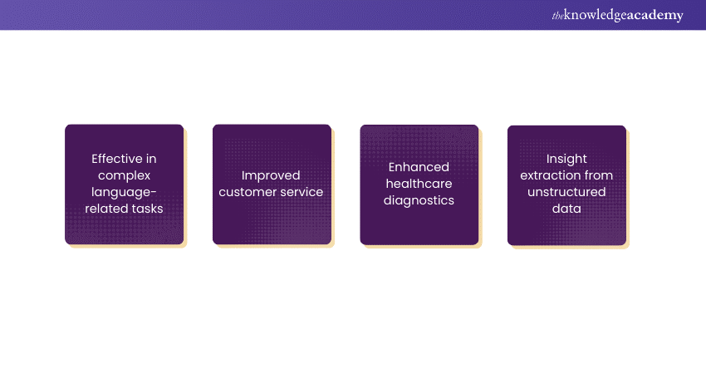

Investments in Natural Language Processing (NLP) are rising as its transformative potential across industries becomes clearer. With applications ranging from chatbots to healthcare diagnostics, NLP's versatility is driving demand. The rise of big data and automation further fuels investment, as businesses seek to extract insights and improve efficiency. Advances like transformer models and pre-trained language representations have also caught investors' attention, boosting NLP's capabilities. As a result, venture capitalists and tech giants are increasingly funding NLP startups and research, fueling growth in this promising field.

**b) Transitioning from Human-computer Interaction to Conversational Interfaces for improved service desk responses**

The shift from traditional human-computer interaction (HCI) to conversational interfaces marks a major change in service desk responses, offering improved user experience and efficiency. Unlike HCI, which relied on graphical or command-line interfaces, conversational interfaces use NLP and AI to enable intuitive, human-like interactions. Tools like chatbots and virtual assistants respond to user queries in natural language, simplifying communication and enabling real-time, 24/7 support. This transition enhances accessibility, reduces response times, and boosts customer satisfaction, making it a strategic move for organizations focused on user-centric experiences.

**c) Enterprise exploration of NLG for text generation**

Enterprises are increasingly adopting Natural Language Generation (NLG) to automate the creation of human-like text from structured data. NLG enhances content creation, improving efficiency, consistency, and accuracy. It enables the production of personalized, high-quality content at scale, such as reports, articles, and product descriptions. Additionally, NLG transforms raw data into actionable insights, aiding decision-making and understanding. By leveraging NLG, businesses can deliver dynamic marketing, personalized recommendations, and interactive chatbot experiences, driving better customer engagement and business outcomes.

**d) Growing adoption of sentiment analysis across diverse industry sectors**

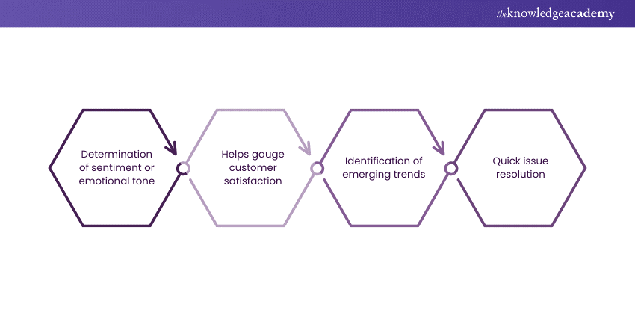

The growing use of sentiment analysis across industries marks a shift in how businesses understand and respond to customer feedback. This NLP technology analyzes text data to determine emotional tone, providing valuable insights from reviews, social media, and surveys. In retail, it helps gauge customer satisfaction and improve products, while in finance, it aids in monitoring market sentiment and managing risk. In healthcare, sentiment analysis enhances patient care and detects issues like adverse medication reactions. As demand for these solutions grows, sentiment analysis continues to drive data-driven decision-making, improve customer experiences, and provide a competitive edge.

**e) Advancements in humanoid robotics**

Advancements in humanoid robotics have made significant strides in mimicking human behaviour and interaction, revolutionizing sectors like healthcare and manufacturing. Breakthroughs in mobility, dexterity, and sensory perception allow robots to perform complex tasks with precision. AI and machine learning enable robots to learn and adapt to dynamic environments, improving human-robot interactions. These innovations are also inspiring new NLP projects to enhance communication. As research continues, the potential for humanoid robotics to transform industries and improve lives is vast.

**f) Increasing ubiquity of voice biometrics**

Voice biometrics are becoming increasingly popular as a secure, convenient alternative to traditional authentication methods. By using unique vocal characteristics, they verify identities and are widely used in sectors like finance, healthcare, and telecommunications. Advancements in machine learning and signal processing have improved their accuracy, making them an essential part of modern security systems and providing seamless, frictionless user experiences.

**Growing adoption of sentiment analysis across sectors**

Sentiment analysis, leveraging natural language processing, is increasingly adopted across sectors. From retail to finance and healthcare, businesses utilise it to extract insights from customer feedback, social media, and surveys. Enhancing decision-making, it gauges sentiment trends, boosts customer satisfaction, and aids in market monitoring, shaping strategic responses.

**a) Finance**

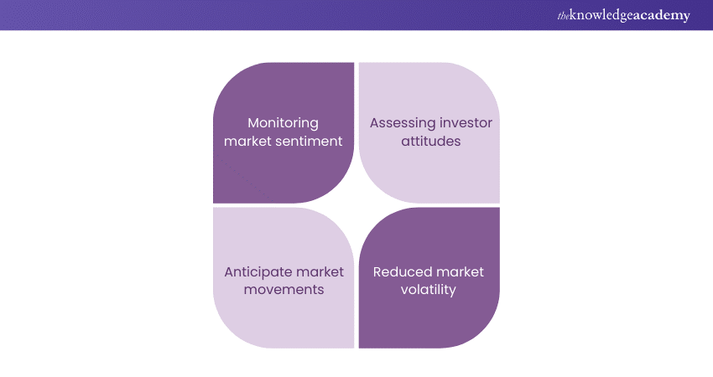

In finance, sentiment analysis is swiftly adopted to monitor market sentiment and gauge investor attitudes towards assets or companies. By analysing news articles, social media posts, and financial reports, institutions can anticipate market movements, identify emerging trends, and assess investment risks.

This technology aids in making informed decisions, improving portfolio management, and minimising market volatility. Additionally, sentiment analysis enables financial institutions to enhance customer service by promptly addressing concerns and adapting products to meet evolving consumer preferences.

**b) HR**

In HR, sentiment analysis is increasingly adopted to gauge employee satisfaction, engagement, and sentiment towards organisational policies or initiatives. By analysing employee feedback, social media posts, and surveys, HR departments can identify potential issues, improve workplace culture, and address concerns proactively.

Moreover, this technology aids in talent management, employee retention, and fostering a positive work environment. Additionally, sentiment analysis enables HR professionals to tailor strategies and interventions to enhance employee well-being and productivity effectively.

**c) E-commerce**

In e-commerce, sentiment analysis is gaining traction to understand customer opinions, preferences, and sentiments towards products or services. By analysing customer reviews, social media conversations, and online discussions, e-commerce companies can gain insights into consumer satisfaction, identify emerging trends, and optimise marketing strategies.

Furthermore, this technology aids in improving product offerings, enhancing customer experiences, and increasing brand loyalty. Additionally, sentiment analysis enables e-commerce businesses to address customer concerns promptly and personalise recommendations to meet individual needs effectively.

**CONCLUSION**

NLP technology has emerged as a transformative force across various industries, revolutionizing how businesses interact with customers, process information, and make data-driven decisions. From improving customer service with chatbots to enhancing data insights and automating content creation, NLP's applications are vast and continue to evolve. As AI and machine learning advancements propel NLP forward, its potential to streamline processes, improve efficiency, and personalize experiences will only grow. With increasing adoption across sectors like healthcare, finance, and retail, NLP is poised to be a cornerstone of future technological advancements, shaping the way humans and machines communicate and collaborate.